Semester 1 Examination, 2003

Question/Answer Booklet

CHEMISTRY

NAME: _______________________________________

CLASS: _______________________________________

Time allowed for this paper
Reading time before commencing work: Ten minutes
Working time for paper: Two hours

Material required/recommended for this paper

To be provided by the supervisor
This Question/Answer Booklet
Separate Multiple Choice Answer Sheet
Chemistry Data Sheet

To be provided by the candidate
Standard Items: Pens, pencils, eraser or correction fluid, ruler

Special Items: A 2B, B or HB pencil for the Separate Multiple Choice Answer Sheet and calculators satisfying the conditions set by the Curriculum Council for this subject.

Important note to candidates
No other items may be taken into the examination room. It is your responsibility to ensure that you do not have any unauthorised notes or other items of a non-personal nature in the examination room. If you have any unauthorised material with you hand it to the supervisor before reading any further.
STRUCTURE OF PAPER

Part | Format | No of Questions Set | No of Questions to be Attempted | Recommended Time (Approx) /Minutes | Marks Allocated
1 | Multiple Choice | 20 | ALL | 35 | 30 (30%)
2 | Short Answers | 6 | ALL | 40 | 30 (30%)
3 | Calculations | 4 | ALL | 30 | 30 (30%)
4 | Extended Answers | 2 | 1 | 15 | 10 (10%)
 |  |  |  | Total marks | 100 (100%)

Instructions To Candidates

1. The rules for the conduct of the Tuart College Semester Examinations are the same as those for the conduct of the Tertiary Entrance Examinations and are detailed in the booklet TEE Handbook. Sitting this examination implies that you agree to abide by these rules.

2. Answer the questions according to the following instructions:

Part 1 Answer all questions, using a 2B, B or HB pencil, on the separate Multiple Choice Answer Sheet. Do not use a ballpoint or ink pen.

If you consider that two or more of the alternative responses are correct, choose the one you think is best. If you think you know an answer, mark it even if you are not certain you are correct. Marks will not be deducted for incorrect answers.

Feel free to write or do working on the question paper; many students who score high marks in the Multiple Choice Section do this.

Part 2, 3 and 4 Write your answers in the spaces provided in this Question/Answer Booklet. A blue or black ball point or ink pen should be used.
Questions containing specific instructions to show working should be answered with a complete, logical, clear sequence of reasoning showing how the final answer was arrived at. Correct answers which do not show working will not be awarded full marks.

3. The examiners recommend that you spend your reading time mainly reading the instructions to candidates and Parts 2, 3 and 4.

4. Chemical equations
For full marks, chemical equations should refer only to those species consumed in the reaction and new species produced. These species may be ions [for example Ag⁺(aq)], molecules [for example NH₃(g),NH₃(aq), CH₃COOH($ℓ$),CH₃COOH(aq)] or solids [for example BaSO₄(s),Cu(s) Na₂CO₃(s)].

PART 1 (30 marks = 30% of paper)

Answer ALL questions in Part 1 on the Separate Multiple Choice Answer Sheet provided, using a 2B, B, or HB pencil. Each question in this part is worth 1½ marks.

1. On going down a column of the periodic table which one of the following statements is TRUE?

(a) Atomic size generally decreases.
(b) Ionisation energy usually decreases.
(c) The number of valence electrons increases.
(d) The number of valence electrons decreases.

Questions 2 and 3 concern the element magnesium (Mg) which has atomic mass 24.32 and atomic number 12. Magnesium has three naturally-occurring isotopes having mass numbers 24, 25 and 26.

2. Which of the following statements about magnesium is WRONG?

(a) Isotope 24 is the most abundant.
(b) All atoms of Mg have 12 protons.
(c) All atoms of Mg have identical nuclei.
(d) The three isotopes of Mg have similar properties except mass.

3. A magnesium ion (Mg⁺²) may have which one of the following combinations of particles?

(a) 10 electrons, 12 protons and 14 neutrons.
(b) 10 electrons, 14 protons and 12 neutrons.
(c) 10 electrons, 14 protons and 10 neutrons.
(d) 12 electrons, 12 protons and 12 neutrons.

4. The CO₂ molecule is linear and the SO₂ molecule is bent or V-shaped. If both carbon to oxgen and sulfur to oxygen bonds are polar, which one of the following is true?

(a) Both CO₂ and SO₂ are polar, but CO₂ is more polar than SO₂.
(b) Both CO₂ and SO₂ are polar, but SO₂ is more polar than CO₂.
(c) The shapes allow neither molecule to be polar.
(d) SO₂ is polar, but CO₂ is not.

Question 5 and 6 refer to the preparation of phosphoric acid by the following reaction:

P_{4(s)} + 5O_{2(g)} + 6H₂O → 4H₃PO₄ Atomic Masses

H = 1.0
O = 16.0
P = 31.0

5. The volume of oxygen gas (O_{2(g)}) measured at STP, required to produce 784 g of H₃PO₄ is:

(a) 10.0 L
(b) 112 L
(c) 179.2 L
(d) 224 L
6. The weight of H₃PO₄ which could be produced from 124 g of P₄ is

(a) 98.0 g
(b) 124 g
(c) 392 g
(d) 496 g

7. Which one of the following properties would be possible for both strongly acidic and strongly basic solutions?

(a) Solution has a hydrogen ion concentration of 1.0 x 10⁻⁷ mol L⁻¹
(b) Solution turns blue litmus red.
(c) Solution tastes sour.
(d) Solution is a very good conductor of electricity.

8. Which of the following species could have the following electron configuration?

1s²2s²2p⁶3s²3p⁶3d¹⁰4s²4p⁶

(a) Br ⁻
(b) Rb⁺
(c) Kr
(d) All of the above

9. Which of the following would conduct an electric current?

1. a crystal of sodium chloride
2. molten silver nitrate
3. an aqueous solution of ammonium sulfate
4. magnesium metal

(a) 1, 2 and 3 only.
(b) 2, 3 and 4 only.
(c) 2 and 3 only.
(d) 2 and 4 only.

10. When 1.0 mol L⁻¹ aqueous solutions of the substances in each of the following pairs are mixed, in which cases will precipitates be formed?

1. AgNO₃ and NaC
2. CaC₂ and (NH₄)₂CO₃
3. Ba(NO₃)₂ and K₂SO₄
4. KNO₃ and MgC₂

(a) 1, 2 and 3 only.
(b) 1 and 3 only.
(c) 2 and 4 only.
(d) 1 and 2 only.

11. Which substance involves bonding that is mainly ionic?

(a) ice, H₂O(s)
(b) liquid ammonia, NH₃()
(c) solid silicon dioxide, SiO₂(s)
(d) solid cesium fluoride, CsF(s)

12. Which, if any, of the following representations of valence electrons, could be expected to form a network solid?

s p

↑
(a)
↑↓
↑

(b)
↑↓
↑
↑

(c)
↑↓
↑↓
↑
↑
(d)

13. In which of the following reactions is water behaving as an acid?

(a) H₂O_{(g)} + C_{(s)}  H_{2(g)} + CO_{(g)}
(b) H₂O_{()} + NH_{3(g)}  NH₄⁺_{(aq)} + OH⁻_{(aq)}
(c) HCO₃⁻_{(aq)} + H₂O_{()}  CO₃²⁻_{(aq)} + H₃O⁺_{(aq)}
(d) H₂O_{()} + HC_{(g)}  H₃O⁺_{(aq)} + C⁻_{(aq)}

14. The reaction A + B  C + D may be said to be at equilibrium when

(a) all four species A, B, C and D can be detected in the reaction mixture.
(b) the molar ratios A:B and C:D are both 1.00.
(c) the concentrations of A, B, C and D are separately constant with time.
(d) the sum of the concentrations of A and B is equal to the sum of the concentrations of
C and D

15. A closed vessel contains nitrogen and hydrogen in equilibrium with NH₃, as shown by the equation below.

N_{2(g)} + 3H_{2(g)}  2NH_{3(g)} ΔH = -92 kJ mol⁻¹

Which one of the following procedures will shift the equilibrium position to the right, that is produce more NH₃?

(a) Increasing the pressure of the system.
(b) Increasing the temperature of the system.
(c) Introduction of an inert gas into the system.
(d) Addition of a catalyst to the system.

16. In which one of the following reactions will the equilibrium position be unaffected by a change in volume?

(a) N_{2(g)} + O_{2(g)}  2NO_{(g)} ΔH = + 180 kJ mol⁻¹
(b) N_{2(g)} + 3H_{2(g)}  2NH_{3(g)} ΔH = - 92 kJ mol⁻¹
(c) 2SO_{3(g)}  2SO_{2(g)} + O_{2(g)} ΔH = + 380 kJ mol⁻¹
(d) C₂H_{6(g)}  C₂H_{4(g)} + H_{2(g)} ΔH = + 138 kJ mol⁻¹

17. What volume of 0.500 mol L⁻¹ barium bromide would contain 0.100 mol of bromide ion?

(a) 1.00 x 10² mL
(b) 2.00 x 10² mL
(c) 5.00 x 10¹ mL
(d) 4.00 x 10² mL

18. 5.0 mL of 0.60 mol L⁻¹ sodium chloride solution has 15 mL of water added to it. The new concentration of the solution is

(a) 0.20 mol L⁻¹
(b) 2.4 mol L⁻¹
(c) 0.60 mol L⁻¹
(d) 0.15 mol L⁻¹

19. Which of the following reaction path represents an endothermic reaction?
R denotes reactants,
P denotes products

Energy
Energy
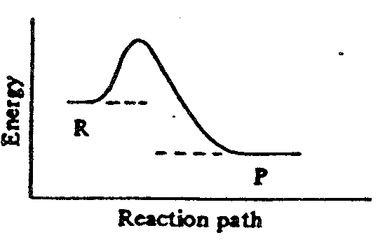
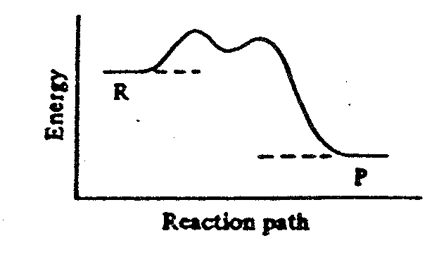
(a)
(c)

Reaction path
Reaction path

Energy
Energy
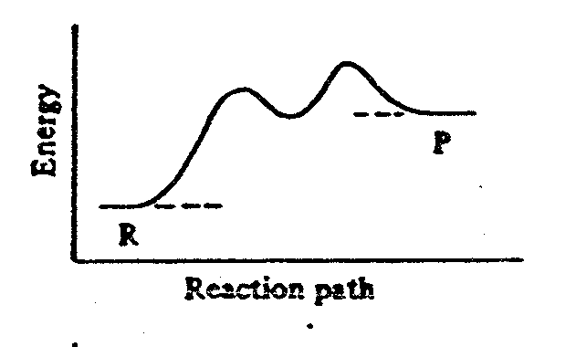
(b)
(d)
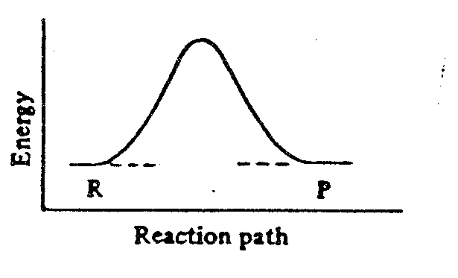

Reaction path

Reaction path

20. The change in energy during a chemical reaction is shown below. Energy changes I and II are also shown.
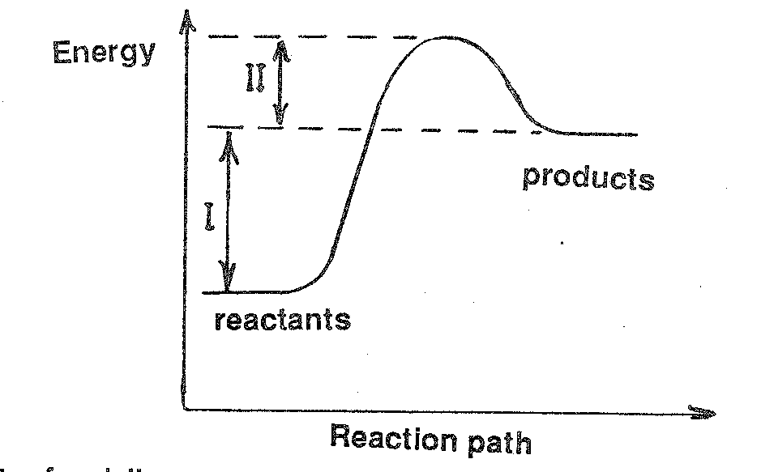
Energy
products

I

II

Reaction path
reactants

The effect of adding a positive catalyst to the system is to

(a) increase the size of II only.
(b) decrease the size of II only.
(c) increase the size of I and decrease the size of II.
(d) decrease the size of I and increase the size of II.

END OF PART 1
PART 2 (30 marks = 30% of paper)

Answer ALL questions in Part 2 in the spaces provided below. This part is worth 30 marks
(30% of the total).

- Write equations for any reactions that occur in the following procedures. If no reaction occurs write "no reaction".

In each case describe in full what you observe, including any
* colours
* odours
* precipitates (give the colour)
* gases evolved (give the colour or describe as colourless)

If a reaction occurs but the change is not visible, you should state this.

(a) Chromium metal is added to a solution of sodium hydroxide

Equation

Observation

[2 marks]

(b) A strip of magnesium is added to a solution of copper (II) sulfate

Equation

Observation

[2 marks]

(c) Solutions of lead (II) nitrate and rubidium iodide (RbI) are mixed:

Equation

Observation

[2 marks]

2. Write the name or formula of a substance whose properties match those described:

(a) A highly polar molecular substance that is very soluble in water. Individual molecules are described as having a pyramidal shape.

______________________________________________________________________

(b) Combines with another element by sharing one pair of valence electrons. When combined with hydrogen it forms molecules that exhibit hydrogen bonding and are acidic.

______________________________________________________________________

(c) Has a very high first ionisation energy, a very low boiling point and does not form bonds with the two elements immediately before or after it in the periodic table.

______________________________________________________________________

(d) In its pure form it is very malleable and ductile and reacts vigorously with water (although most other elements of the same group are more reactive); salts containing this ion are always soluble.

______________________________________________________________________
[4 marks]

3. An important chemical reaction is the combustion of petrol in the cylinder of a motor of a vehicle.

C₇H_{16()} + 11O_{2(g)} → 7CO_{2(g)} + 8H₂O_{(g)} + Energy

Use the collision theory to explain 4 ways by which the rate of this reaction could be increased.

(a) ______________________________________________________________________

______________________________________________________________________

______________________________________________________________________

(b) ______________________________________________________________________

______________________________________________________________________

______________________________________________________________________

(c) ______________________________________________________________________

______________________________________________________________________

______________________________________________________________________

(d) ______________________________________________________________________

______________________________________________________________________

______________________________________________________________________
[4 marks]
4. Give a chemical test and observations that could be used to distinguish between the following pairs of substances. You need to clearly state the expected observation for each substance tested. No equations need be given.

(a) 2 mol L⁻¹ H₂SO₄ and 2 mol L⁻¹ HNO₃

TEST: _____________________________________________________________________

OBSERVATION: ____________________________________________________________

___________________________________________________________________________

(b) Two white powders: magnesium hydroxide and aluminium hydroxide

TEST: _____________________________________________________________________

OBSERVATION: ____________________________________________________________

___________________________________________________________________________

(c) Two colourless solutions: potassium ethanoate and potassium chloride.

TEST: _____________________________________________________________________

OBSERVATION: ____________________________________________________________

___________________________________________________________________________
[6 marks]

5. Use ticks (√) in the appropriate spaces to classify each of the following solutions

Solutions | Strong  Electrolyte | Weak  Electrolyte | Non  Electrolyte | Strong  Conductor | Weak  Conductor | Non  Conductor
Calcium
Hydroxide
Nitric Acid

Sugar

Ammonia

[4 marks]

6. Draw electron dot diagrams for the following species and describe the shape. Indicate if the species would be polar or not.

Use dots (•) to show all valence electrons

Species | Electron dot diagram | Name of shape | Polar or Not?
hydrogen sulfite ion
HSO₃⁻

beryllium difluoride
BeF₂

tellurium dihydride
TeH₂

[6 marks]

END OF PART 2
PART 3 (30 marks = 30% of paper)

Answer ALL questions in Part 3. The calculations are to be set out in detail in this Question/Answer Booklet. Marks will be allocated for correct equations and clear setting out, even if you cannot complete the problem. When questions are divided into sections, clearly distinguish each section using (a), (b) and so on. Correct final numerical answers to three (3) significant figures where appropriate, and provide units where applicable. Information which may be necessary for solving the problems is located on the separate Chemistry Data Sheet. Show clear reasoning: if you don’t, you will lose marks. This part carries 30 marks (30% of the total)

1. A sample of 3.164 g of a chlorofluorocarbon (a compound containing carbon, fluorine and chlorine only) was analysed as follows.

All the carbon in the sample was converted into carbon dioxide gas, and all its chlorine was converted into hydrochloric acid.

The carbon dioxide has a mass of 1.366 g and the complete neutralisation of the hydrochloric acid required 30.93 mL of 2.007 mol L⁻¹ sodium hydroxide solution.

Another sample of the same gaseous compound of mass 1.322g occupied 0.1453 L at S.T.P.

(a) Determine the empirical formula of the compound.
[5 marks]

(b) Determine the molecular formula of the compound.
[2 marks]
__________________________________________________________________________
__________________________________________________________________________
__________________________________________________________________________
__________________________________________________________________________
__________________________________________________________________________
__________________________________________________________________________
__________________________________________________________________________
__________________________________________________________________________
__________________________________________________________________________
__________________________________________________________________________
__________________________________________________________________________
__________________________________________________________________________
__________________________________________________________________________
__________________________________________________________________________
__________________________________________________________________________
__________________________________________________________________________
__________________________________________________________________________
__________________________________________________________________________
__________________________________________________________________________
__________________________________________________________________________
__________________________________________________________________________
__________________________________________________________________________
__________________________________________________________________________
__________________________________________________________________________
__________________________________________________________________________
__________________________________________________________________________
__________________________________________________________________________
__________________________________________________________________________
__________________________________________________________________________
__________________________________________________________________________
__________________________________________________________________________
__________________________________________________________________________
__________________________________________________________________________
__________________________________________________________________________
__________________________________________________________________________
__________________________________________________________________________
__________________________________________________________________________
__________________________________________________________________________
__________________________________________________________________________
__________________________________________________________________________
__________________________________________________________________________
__________________________________________________________________________
__________________________________________________________________________
__________________________________________________________________________
__________________________________________________________________________
__________________________________________________________________________
__________________________________________________________________________
__________________________________________________________________________
__________________________________________________________________________
__________________________________________________________________________
__________________________________________________________________________
__________________________________________________________________________
__________________________________________________________________________
__________________________________________________________________________
__________________________________________________________________________
__________________________________________________________________________
__________________________________________________________________________
__________________________________________________________________________
__________________________________________________________________________
__________________________________________________________________________
__________________________________________________________________________
__________________________________________________________________________
__________________________________________________________________________
__________________________________________________________________________
__________________________________________________________________________
__________________________________________________________________________
__________________________________________________________________________
__________________________________________________________________________
__________________________________________________________________________
__________________________________________________________________________
__________________________________________________________________________
__________________________________________________________________________
__________________________________________________________________________
__________________________________________________________________________
__________________________________________________________________________
__________________________________________________________________________
__________________________________________________________________________
__________________________________________________________________________
__________________________________________________________________________
__________________________________________________________________________
__________________________________________________________________________
__________________________________________________________________________

2. A student dissolved 20.82 g of pure (anhydrous) barium chloride in 500 mL of solution. She then took a 150.0 mL sample of this solution and added to it 300.0 mL of a
0.100 mol L⁻¹ sodium sulfate solution. A white precipitate was obtained. This precipitate was filtered, dried and weighed.

(a) What mass of precipitate would be formed?
[4 marks]

(b) Calculate the concentration of all ions which remain in the final solution
after filtering.
[4 marks]

__________________________________________________________________________
__________________________________________________________________________
__________________________________________________________________________
__________________________________________________________________________
__________________________________________________________________________
__________________________________________________________________________
__________________________________________________________________________
__________________________________________________________________________
__________________________________________________________________________
__________________________________________________________________________
__________________________________________________________________________
__________________________________________________________________________
__________________________________________________________________________
__________________________________________________________________________
__________________________________________________________________________
__________________________________________________________________________
__________________________________________________________________________
__________________________________________________________________________
__________________________________________________________________________
__________________________________________________________________________
__________________________________________________________________________
__________________________________________________________________________
__________________________________________________________________________
__________________________________________________________________________
__________________________________________________________________________
__________________________________________________________________________
__________________________________________________________________________
__________________________________________________________________________
__________________________________________________________________________
__________________________________________________________________________
__________________________________________________________________________
__________________________________________________________________________
__________________________________________________________________________
__________________________________________________________________________
__________________________________________________________________________
__________________________________________________________________________
__________________________________________________________________________
__________________________________________________________________________
__________________________________________________________________________
__________________________________________________________________________
__________________________________________________________________________
__________________________________________________________________________
__________________________________________________________________________
__________________________________________________________________________
__________________________________________________________________________
__________________________________________________________________________
__________________________________________________________________________
__________________________________________________________________________
__________________________________________________________________________
__________________________________________________________________________
__________________________________________________________________________
__________________________________________________________________________
__________________________________________________________________________
__________________________________________________________________________
__________________________________________________________________________
__________________________________________________________________________
__________________________________________________________________________
__________________________________________________________________________
__________________________________________________________________________
3. A sample of a copper ore contains copper (II) carbonate as the only copper containing substance. 5.00 g of this ore is treated with 25.0 mL of 0.250 mol L⁻¹ H₂SO₄ solution and the resultant mixture allowed to stand until reaction is complete. All dissolved CO₂ is then driven from the solution by heating. The resultant solution is then titrated with a
0.250 mol L⁻¹ solution of NaOH. 17.60 mL of the NaOH solution was required to neutralize the excess acid remaining. CuCO₃ is the only substance present that reacts with acid.

Calculate the percentage by mass of copper in the sample of copper ore.
[8 marks]

__________________________________________________________________________
__________________________________________________________________________
__________________________________________________________________________
__________________________________________________________________________
__________________________________________________________________________
__________________________________________________________________________
__________________________________________________________________________
__________________________________________________________________________
__________________________________________________________________________
__________________________________________________________________________
__________________________________________________________________________
__________________________________________________________________________
__________________________________________________________________________
__________________________________________________________________________
__________________________________________________________________________
__________________________________________________________________________
__________________________________________________________________________
__________________________________________________________________________
__________________________________________________________________________
__________________________________________________________________________
__________________________________________________________________________
__________________________________________________________________________
__________________________________________________________________________
__________________________________________________________________________
__________________________________________________________________________
__________________________________________________________________________
__________________________________________________________________________
__________________________________________________________________________
__________________________________________________________________________
__________________________________________________________________________
__________________________________________________________________________
__________________________________________________________________________
__________________________________________________________________________
__________________________________________________________________________
__________________________________________________________________________
__________________________________________________________________________
__________________________________________________________________________
__________________________________________________________________________
__________________________________________________________________________
__________________________________________________________________________
__________________________________________________________________________
__________________________________________________________________________
__________________________________________________________________________
__________________________________________________________________________
__________________________________________________________________________
__________________________________________________________________________
__________________________________________________________________________
__________________________________________________________________________
__________________________________________________________________________
__________________________________________________________________________
__________________________________________________________________________
__________________________________________________________________________
__________________________________________________________________________
__________________________________________________________________________
__________________________________________________________________________
__________________________________________________________________________
__________________________________________________________________________
__________________________________________________________________________
__________________________________________________________________________
__________________________________________________________________________
__________________________________________________________________________
4. Solid ammonium carbonate decomposes according to the UNBALANCED equation

(NH₄)₂CO_{3(s)} → NH_{3(g)} + CO_{2(g)} + H₂O_{(g)}

A 12.2 g sample of ammonium carbonate is all decomposed at 175ºC in a sealed gas flask of volume 1.68 L

Calculate

(a) The total number of moles of products formed.
[2 marks]

(b) The pressure in the gas flask.
[3 marks]

(c) The mass of CO₂ produced.
[2 marks]

__________________________________________________________________________
__________________________________________________________________________
__________________________________________________________________________
__________________________________________________________________________
__________________________________________________________________________
__________________________________________________________________________
__________________________________________________________________________
__________________________________________________________________________
__________________________________________________________________________
__________________________________________________________________________
__________________________________________________________________________
__________________________________________________________________________
__________________________________________________________________________
__________________________________________________________________________
__________________________________________________________________________
__________________________________________________________________________
__________________________________________________________________________
__________________________________________________________________________
__________________________________________________________________________
__________________________________________________________________________
__________________________________________________________________________
__________________________________________________________________________
__________________________________________________________________________
__________________________________________________________________________
__________________________________________________________________________
__________________________________________________________________________
__________________________________________________________________________
__________________________________________________________________________
__________________________________________________________________________
__________________________________________________________________________
__________________________________________________________________________
__________________________________________________________________________
__________________________________________________________________________
__________________________________________________________________________
__________________________________________________________________________
__________________________________________________________________________
__________________________________________________________________________
__________________________________________________________________________
__________________________________________________________________________
__________________________________________________________________________
__________________________________________________________________________
__________________________________________________________________________
__________________________________________________________________________
__________________________________________________________________________
__________________________________________________________________________
__________________________________________________________________________
__________________________________________________________________________
__________________________________________________________________________
__________________________________________________________________________
__________________________________________________________________________
__________________________________________________________________________
__________________________________________________________________________
__________________________________________________________________________
__________________________________________________________________________
END OF PART 3
PART 4 (10 marks = 10% of paper)

Answer ONE of the following extended answer questions. Where applicable use equations, diagrams and illustrative examples of the chemistry you are describing.

Marks are awarded for the relevant chemical content of your answer, but you will lose marks if what you write is unclear or lacks coherence. Your answer should be presented in about 1 to 1½ pages.

1. Hydrogen chloride gas is a covalent molecular substance yet, when it dissolves in water, it completely ionises to form hydrochloric acid. Heat is released as it dissolves.

Explain fully the principles of chemistry involved in this process. Your answer should consider bonding, solubility, acidic properties and energy changes.

OR

2. The halogens are a group of elements that have similar properties but they also have differences. Select three similar properties and three different properties of the halogens and clearly explain how these similarities and differences are caused. The properties you select may be physical or chemical properties.

END OF QUESTIONS

Begin your answer to Part 4 here
__________________________________________________________________________
__________________________________________________________________________
__________________________________________________________________________
__________________________________________________________________________
__________________________________________________________________________
__________________________________________________________________________
__________________________________________________________________________
__________________________________________________________________________
__________________________________________________________________________
__________________________________________________________________________
__________________________________________________________________________
__________________________________________________________________________
__________________________________________________________________________
__________________________________________________________________________
__________________________________________________________________________
__________________________________________________________________________
__________________________________________________________________________
__________________________________________________________________________
__________________________________________________________________________
__________________________________________________________________________
__________________________________________________________________________
__________________________________________________________________________
__________________________________________________________________________
__________________________________________________________________________
__________________________________________________________________________
__________________________________________________________________________
__________________________________________________________________________
__________________________________________________________________________
__________________________________________________________________________
__________________________________________________________________________
__________________________________________________________________________
__________________________________________________________________________
__________________________________________________________________________
__________________________________________________________________________
__________________________________________________________________________
__________________________________________________________________________
__________________________________________________________________________
__________________________________________________________________________
__________________________________________________________________________
__________________________________________________________________________
__________________________________________________________________________
__________________________________________________________________________
__________________________________________________________________________
__________________________________________________________________________
__________________________________________________________________________
__________________________________________________________________________
__________________________________________________________________________
__________________________________________________________________________
__________________________________________________________________________
__________________________________________________________________________
__________________________________________________________________________
__________________________________________________________________________
__________________________________________________________________________
__________________________________________________________________________
__________________________________________________________________________
__________________________________________________________________________
__________________________________________________________________________
__________________________________________________________________________
__________________________________________________________________________
__________________________________________________________________________
__________________________________________________________________________
__________________________________________________________________________
__________________________________________________________________________
__________________________________________________________________________
__________________________________________________________________________
__________________________________________________________________________
__________________________________________________________________________
__________________________________________________________________________
__________________________________________________________________________
__________________________________________________________________________
__________________________________________________________________________
__________________________________________________________________________
__________________________________________________________________________
__________________________________________________________________________
__________________________________________________________________________
__________________________________________________________________________
__________________________________________________________________________
__________________________________________________________________________
__________________________________________________________________________
__________________________________________________________________________
__________________________________________________________________________
__________________________________________________________________________
__________________________________________________________________________

END OF PAPER

